Intent Statement
The children at Victoria Community School will have a positive attitude towards English writing. Teachers will guide and nurture each individual on their own personal journey in becoming successful writers. Children will write clearly, accurately, and coherently adapting language and style for a range of contexts, purposes and audiences. A secure understanding of spelling, grammar and punctuation is taught throughout the school. We intend for all children to acquire a rich vocabulary and be able to spell words by effectively applying spelling patterns and rules which they learn. Teachers will expertly model and provide children with the skills to edit and improve their writing both independently and effectively. We believe that children should be encouraged to take pride in their work, in part by developing a legible, joined handwriting style. Children leave Victoria with a deep understanding of different formats and how to construct them effectively.

Implementation: Scheme
Consistent approach to planning.
Medium term plans are completed for each unit of work.
Incidental writing opportunities are planned for the children.

Implementation: Planning
Teachers plan using a MTP proforma for each unit of work. Short term plans are then completed in detail and flip charts are created to support the delivery of the writing lessons. Each piece of writing has a clear audience and purpose. Teachers plan in the grammar required in that style of writing and teach the children to plan their writing effectively. Children then use the scaffolds to produce their writing. Finally, children edit and improve their work using a purple polishing pen.
Intent: Links
Every year group has a ‘Writing Toolkit’ which is based on the National Curriculum.

Writing is linked with the current topic or other areas of the curriculum. Current events are also encouraged to be used to enhance writing.
Implementation: Resources
High quality texts
Picture Books
Video clips
Literacy Shed

Implementation: Lesson Sequence

S Plan?
JS?
Implementation: T & L / Pedagogies
Talk for writing (EYFS) to build on language
Whole class feedback to address common misconceptions
Editing and improving to allow the children to further improve their own work
Teaching to the expected standard so there is no ‘ceiling’ put on the children’s learning
Staff meetings to keep all staff informed of expectations
Implementation: How Groups and Supported (SEND, GDS, PP, Disadvantaged, EAL, New Arrivals)
- Quality First Teaching strategies used to support all learners.
- New arrivals group.
- Use of Visual Aids and Digital resources to enhance the learning.
- BIUB’s used to support children’s writing.
- Word mats to support vocabulary.
- Letter formation aids to support the correct letter formation.
Implementation: Feedback
- Writing Toolkit’s
- Whole class feedback
- Positive praise
- Writing levelled using Staffordshire Assessment Grids each half term.
Implementation: Environment
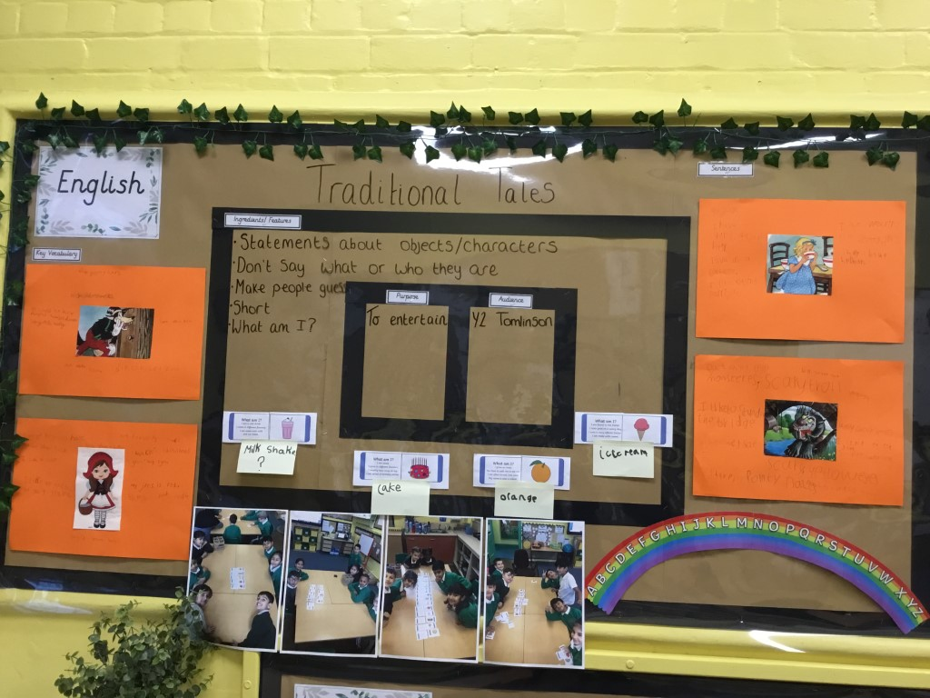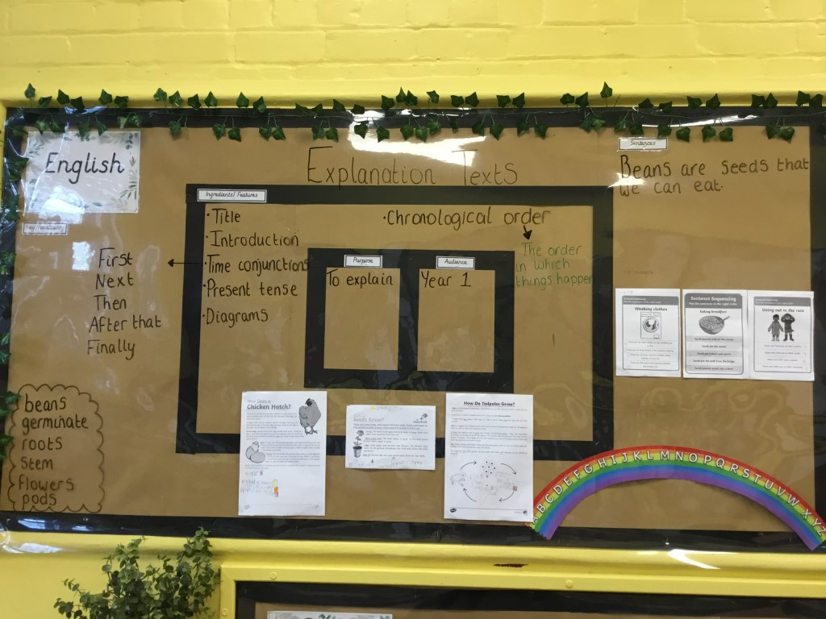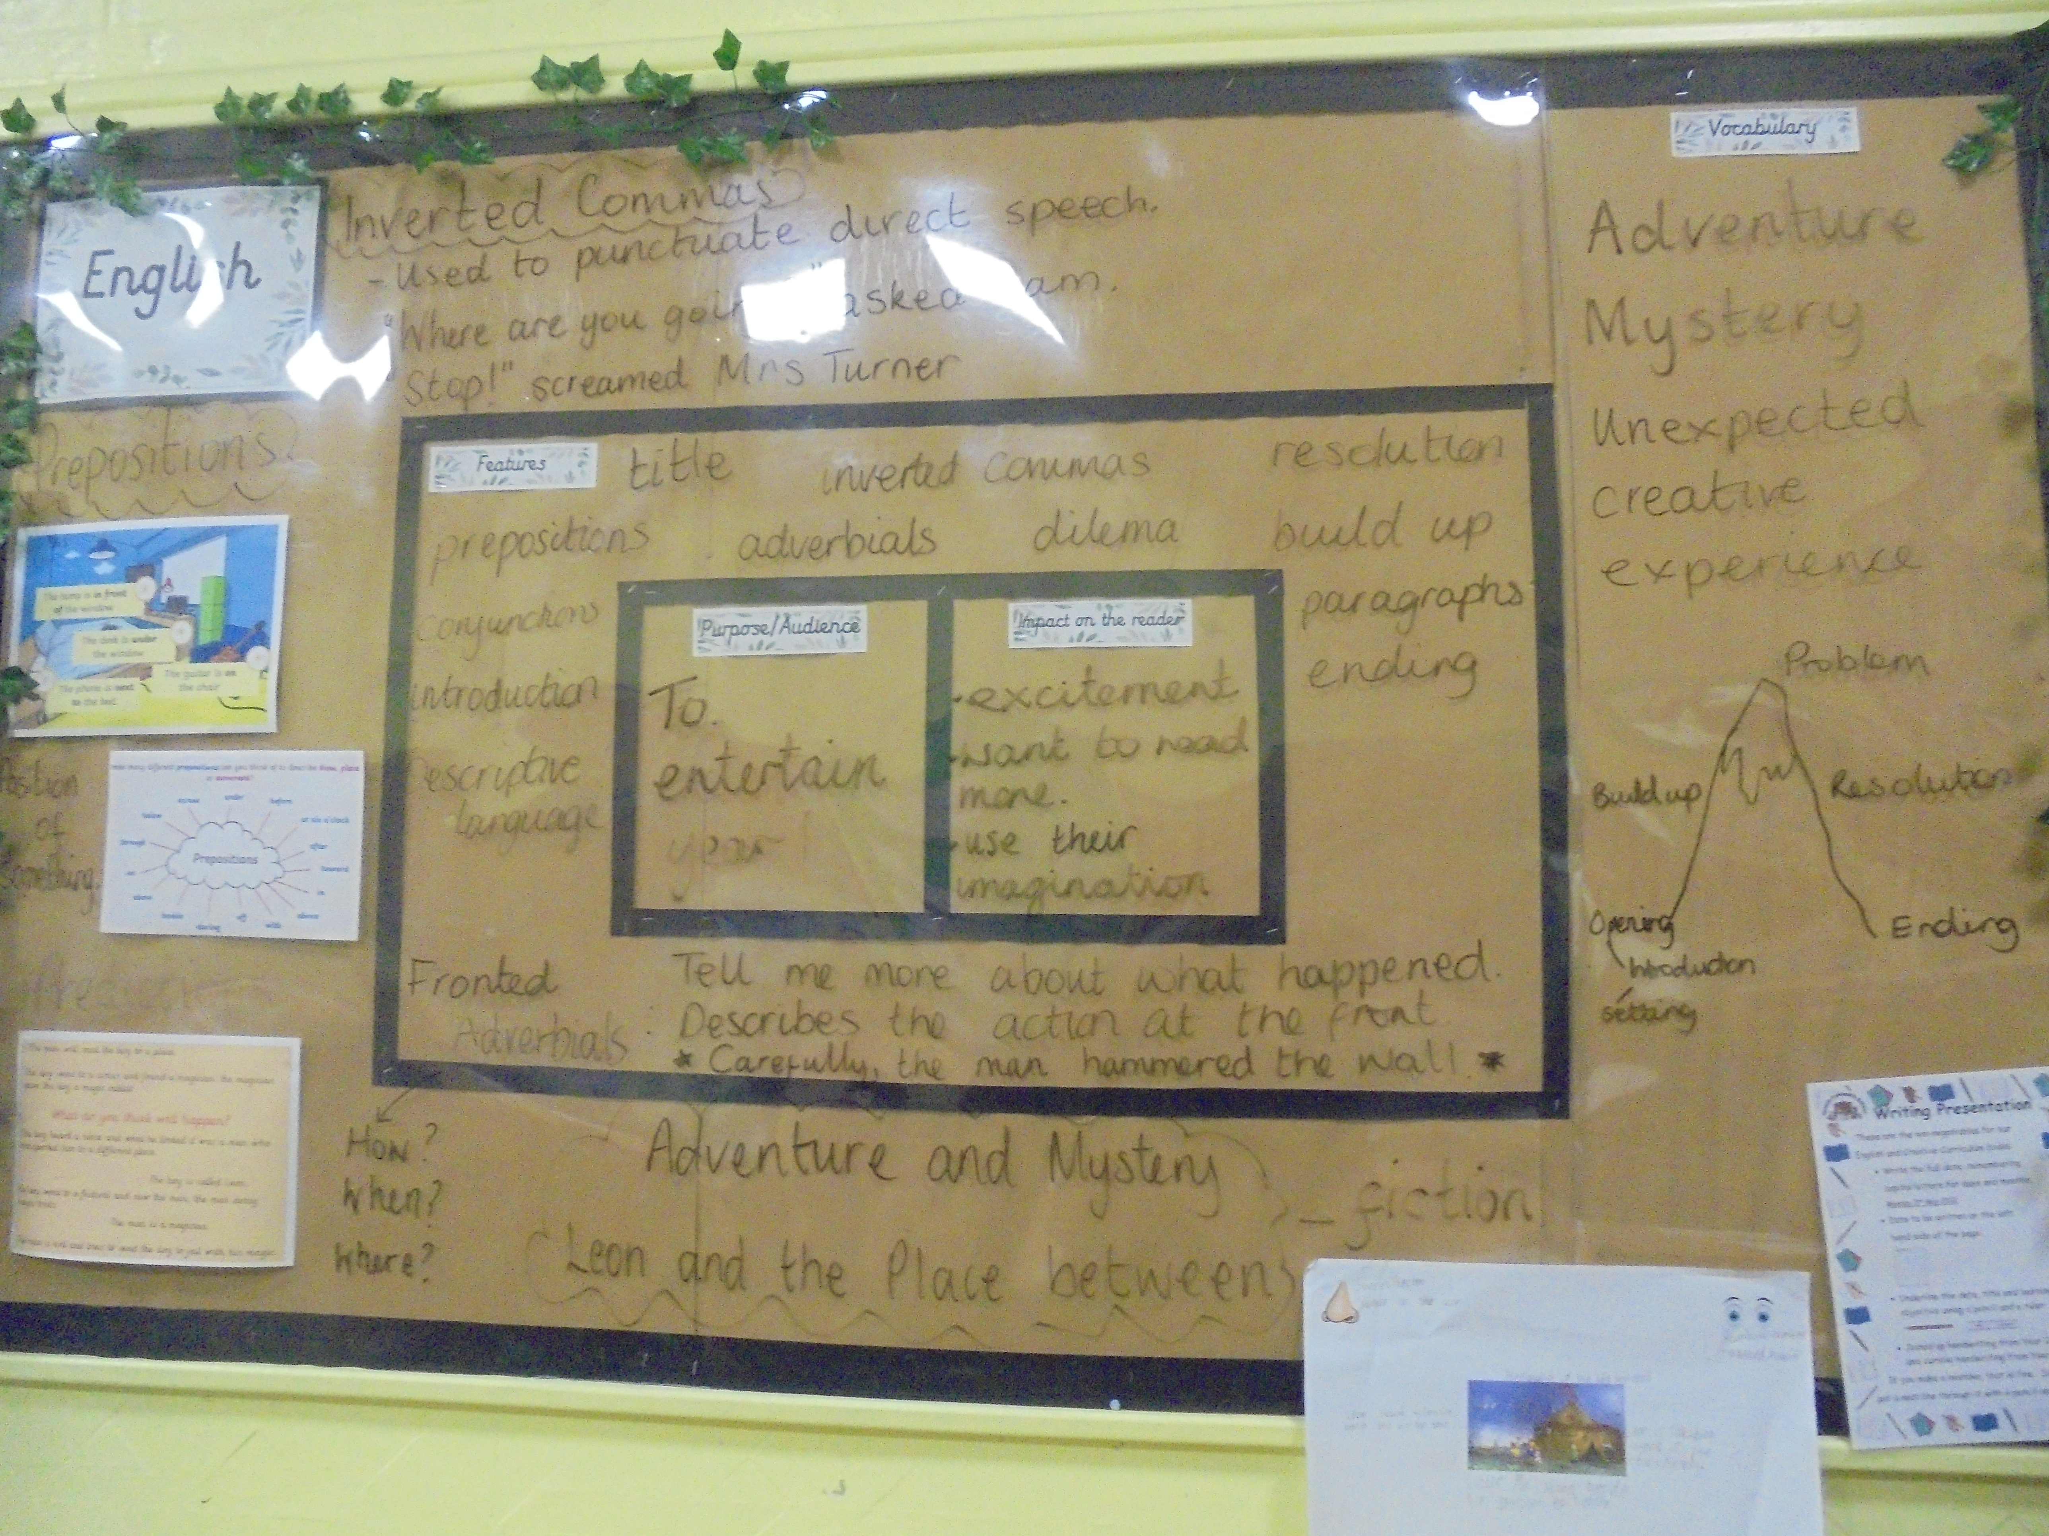
Impact: Monitoring
- Monitoring of medium- and short-term planning.
- Lesson observations
- Observation of writing lessons
- Book scans
- Analysis of Y6 teacher assessment writing
- Moderation and analysis of pupil progress from ALPS in writing
- BRCP termly writing moderation
- Pupil voice
- Staff questionnaires
Impact: Assessment
AFL is to be used on a daily basis to inform next steps and planning ensuring the children progress within their writing skills. Teacher’s to regularly assess using ALPS. End of unit independent pieces of writing are to be completed each half term, in either fiction, non-fiction or poetry and assessed against the National Curriculum expectations, using the Staffordshire Assessment Grids.

