
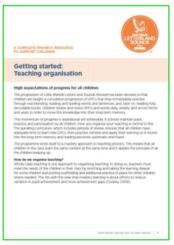
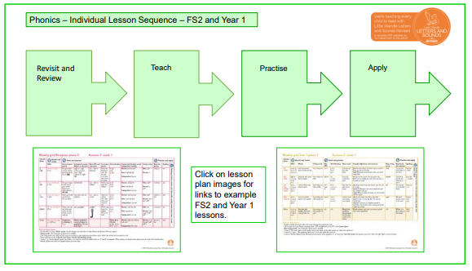
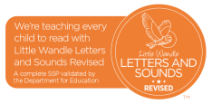
Fidelity to the LW scheme and consistency across all EYFS and Y1 classes is maintained, including planning, terminology, strategies and resources used. Teaching staff regularly refer to the ‘How To’ videos provided by LW to support their fidelity to the scheme. New teaching colleagues (regardless of year group) undertake the full LW training.
Example individual lesson plans for Reception and Year 1
Phonics individual lesson sequence EYFS and Year 1
Intent Statement
The children at Victoria Community School will have a positive attitude towards reading, read for enjoyment and pleasure and develop the life-long skill of reading. Our main priority is reading and is a key driver in our curriculum so that the children can read in all subjects and understand the world around them. At Victoria Community School, we intend that our children become confident and independent readers by the end of Key Stage One. We aim for the children to decode unfamiliar words, where needed, read fluently, comprehend what they read and relate what they read to their own experiences.

Implementation: Scheme
In Reception and Year 1, children are taught Reading through Little Wandle Letters and Sounds Revised, a systematic phonics programme.
Implementation: Planning
Phonics planning is provided by the Little Wandle for Letters and Sounds scheme. Opportunities to enhance cultural capital is planned into the continuous and enhanced provision.
Available on the Little Wandle website for planning:
Weekly grids-these provide the information needed to teach phonics lessons – including guidance to help with organisation of the review word cards. Videos support all teaching and organisation.
Half-termly overview and templates to support teaching.
Match the words to the picture resources to display on your whiteboard for Review lessons.
Keep-up individual and group materials to support children at risk of falling behind.
Reading session templates, Prompt cards and videos for decoding, reading with expression and comprehension.
Intent: Links
Handwriting: can be taught alongside or outside of the phonics lesson using the Phase 2 grapheme information sheets to support with the letter formation phrase and pronunciation phrase for each grapheme. The phonics learned in the daily lessons is reinforced and embedded through other subject areas and within the environment whenever the children are reading, writing and spelling.
Implementation: Resources
All teaching staff across the school have completed the full training programme and are therefore highly skilled in the knowledge, skills and understanding of teaching phonics through the Little Wandle scheme.
• Little Wandle provide ‘How to’ videos for each section of the phonics sessions so that teaching staff can undertake short burst CPD to inform their own teaching. The subject lead will direct staff to this part of the website as part of their weekly coaching sessions.
• Little Wandle provide a full package of resources to use in the classroom to ensure consistency and fidelity to the scheme.
• Big Cat Phonics for Little Wandle Letters and Sounds Revised: fully decodable books matched to LW progression, supporting all phases for Reception and Y1.
Implementation: Lesson Sequence
Implementation: T & L / Pedagogies

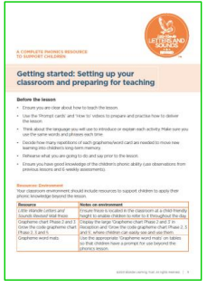
Implementation: How Groups and Supported (SEND, GDS, PP, Disadvantaged, EAL, New Arrivals)
It is important that our approach to teaching phonics and reading is accessible to all learners, regardless of background.
• Teaching staff ensure their mouth is visible at all times and that they’re not covering it with resources, such as grapheme cards.
• We ensure children with hearing and sight impairment are close to us and have a clear view of all the resources.
• If necessary, teacher talk is reduced for children who need more time to process what is being said.
• Use routines to lower cognitive load.
• We ensure the teaching area is uncluttered to minimise distractions and aid focus.
• We think about appropriate adjustments to ensure a child can be included in the lessons, providing children with their own resources (enlarged, if appropriate), cushions to help with core stability, a writing slope to prop up books, etc.
• Daily keep-up outside of the lesson is provided, if required
. • Any additional adults supporting in the lesson are well-trained and are clear about the content of the lesson and how to support children effectively.
• Those children for whom phonics hasn’t worked (or isn’t working) take part in a RIWI intervention with fully trained teaching staff.
Implementation: Feedback
We gather feedback by:
• checking with the whole class;
• choosing two children who are on track;
• choosing two children who may need additional practice; and
• making a list of children who need instant keep-up in the afternoon.

We use the ‘Keep-up teacher’s guide’ to help identify which specific steps need to be practised.
Implementation: Environment

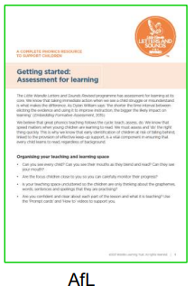
Impact: Monitoring
- Lesson observations / drop-ins.
- Team teaching
- Coaching and mentoring sessions
- Discussions with teachers / teaching assistants.
- Assessment data-analysis of the data
- Book-looks
- Pupil voice
- Colleague voice

Impact: Assessment

Summative assessments are carried out every six weeks of the teaching cycle to help us keep track of pupils’ progress, to inform next steps for teaching and to identify pupils for ‘Keep-up’. These assessments are carried out by the class teacher. These are one-toone assessments that give a clear indication of the AfL progress of each child. Any children that require additional support receive ‘Keep-Up’ interventions in the afternoons.

